1a)

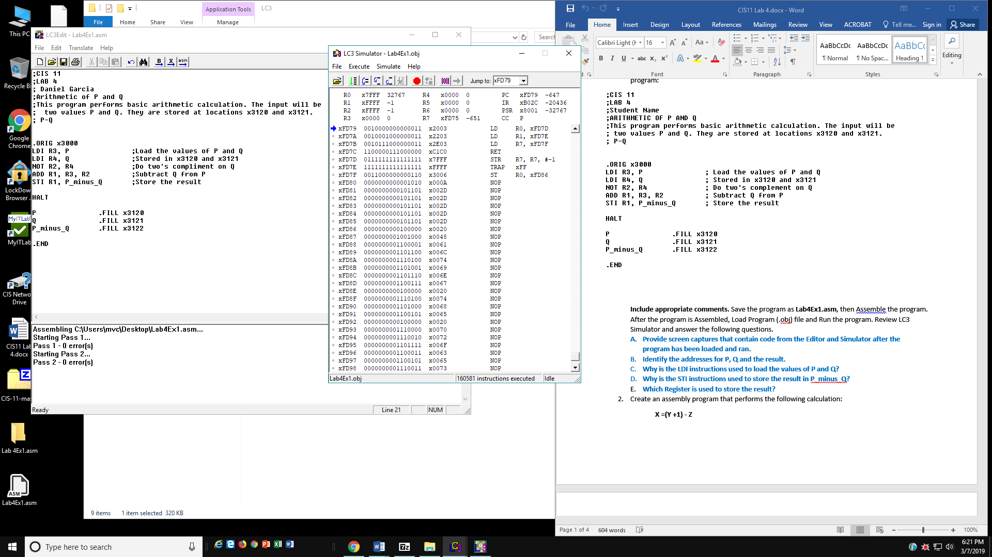

1b) P is at xFD7D, Q is at xFD7E, and the result is at xFD7F

1c) Because you’re referencing memory location

1D) Because you’re storing the result into the memory location indicated by the value that P_minus_Q’s memory location contains

1E)R0?

2a)

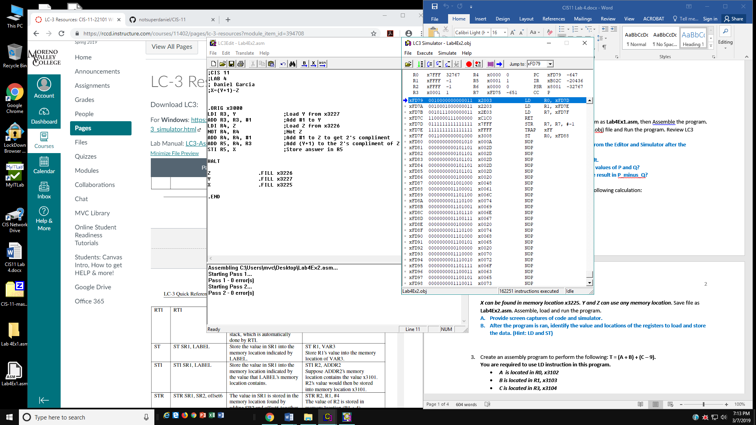

2b) LD R0=xFD7D R1=xFD7E R7=xFD7F

ST R0=XFD88

3a)

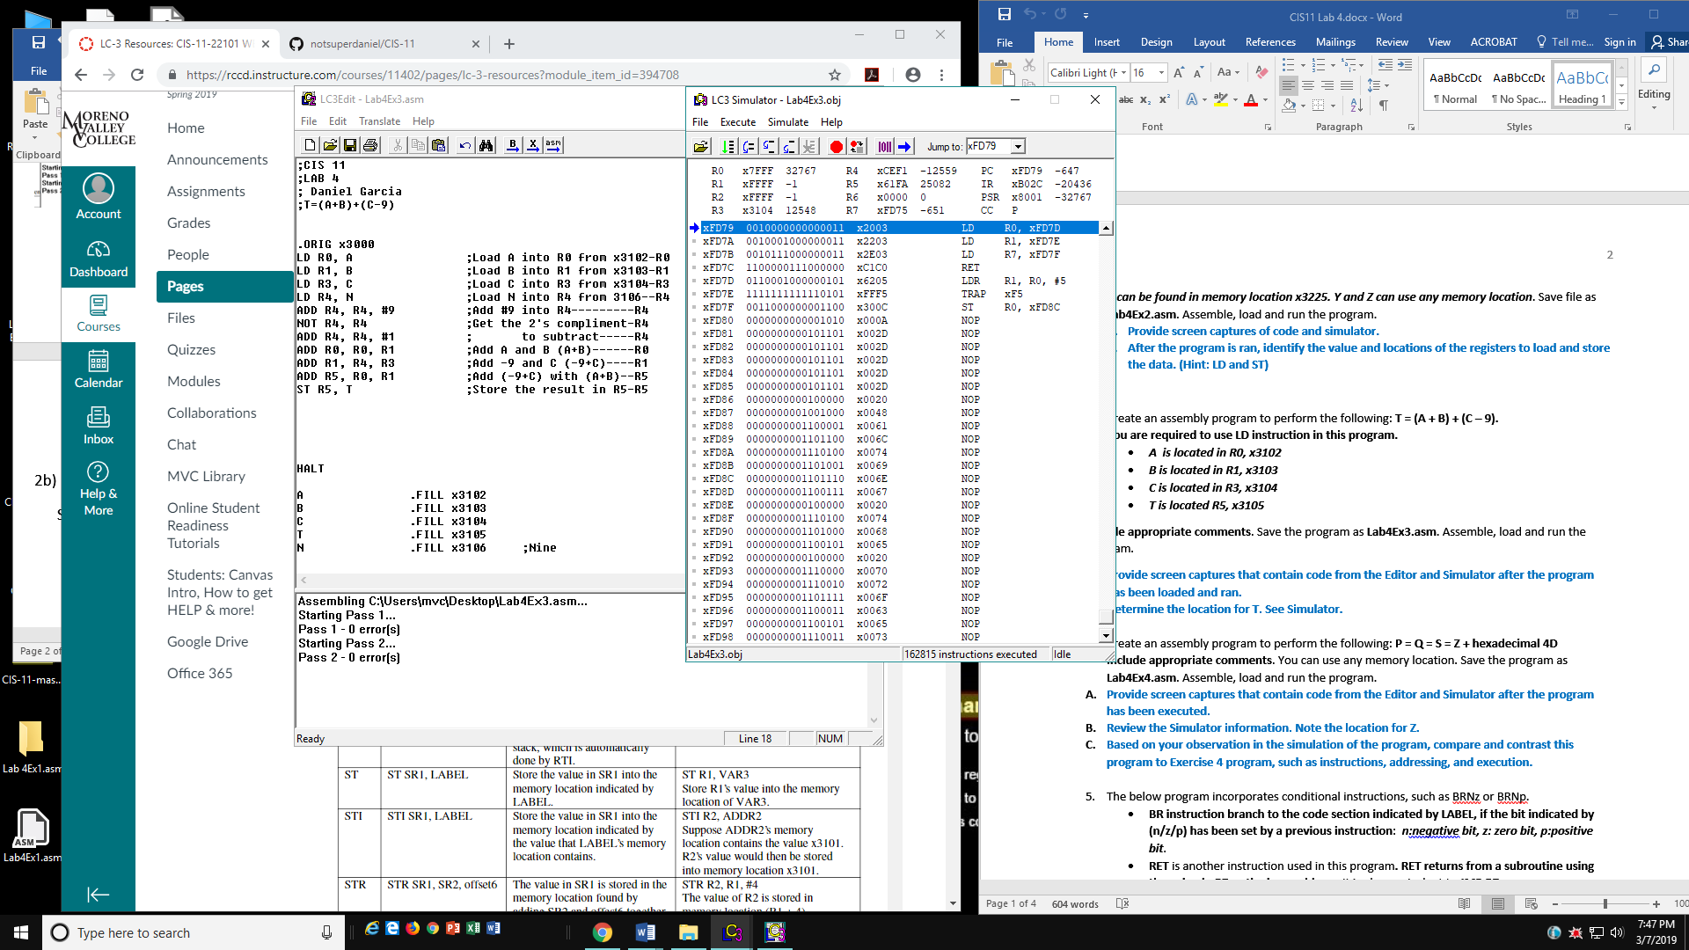

3b) T is located at xFD8C

4A)